(Approx. 673 words)

Some Useful Windows 10 Features
By David Kretchmar, Computer Technician
Sun City Summerlin Computer Club
https://www.scscc.club
dkretch (at) gmail.com

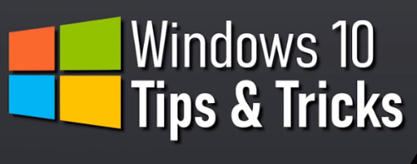
While many users consider Windows 10 the most complicated operating system Microsoft has come up with yet, it does contain a lot of handy new features. Some of these have been present in some form since the beginnings of Windows, and others have been introduced by Microsoft’s newer versions of Windows 10. I personally think Windows 10 is by far the best version of Windows ever, for the built-in security if nothing else. I have never had to remove a virus from an operating system running Windows 10 with Windows Security activated and current, which are the defaults.

Notifications
Windows provides users with popups notifying users of a system or news event. These and pretty much all popups provide a minimum of useful information and are more annoying and distracting than anything else.

Many Sites visited while surfing the Internet will display a popup offering to send you notifications of certain events. I recommend you “Just say no” to this offer, unless the notifications are for something you deem important. Notifications can also come from your system, i.e. you might get a notification that Windows security has completed a scan finding nothing.

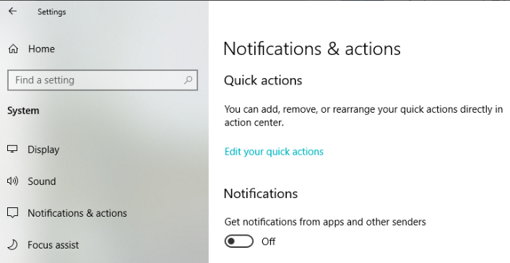
Most users would be best served by turning off notifications completely, and the newer versions of Windows 10 make this easier than ever. Click (clicks are always left-clicks unless otherwise indicated) on the Notifications icon at the far right of your Taskbar, then click on Manage notifications at the top right side of the window that appears. You are in the Notifications and actions section of Settings. The top slider switch provides an opportunity to turn off all notifications. Or if you like you can leave notifications on and in the area below the on/off slider, elect to receive or not receive notification from specific sources.

Dictation
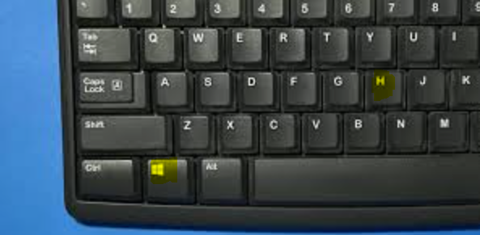
If you haven’t used voice-to-text software in recent years, you will be amazed at how far this technology has come. Windows 10 has been no slouch in applying artificial Intelligence (AI) to this task. You can now dictate into any application. To turn on dictation in Windows 10, hold down the Windows logo key near the lower left-hand corner of your keyboard and press the letter H on your keyboard. A microphone indicator rectangle will appear at the top-center of your screen.

Just place your cursor in any field ready to receive text (like a Word document you are creating) and start talking. Now with a little practice you don’t have to deal with keyboarding; you can dictate your content, just like I did for this sentence. Period.

Snip & Sketch Tool
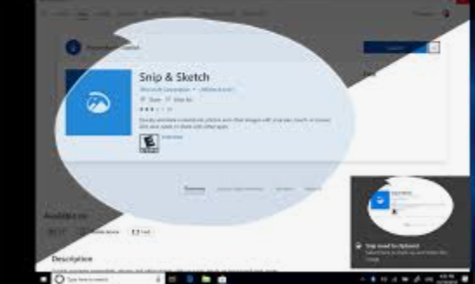
The snipping tool has been in Windows 10 for a number of years, but until recently it couldn’t compete with third party screen capture software.

Snip & Sketch is Windows’ newest, best approach yet to capturing all or part of an image on your screen.
Start by holding down the Windows logo key on your keyboard and pressing Shift and the letter S. This creates a small dialogue bar at the top of your screen where you can choose from rectangular, free form, square, or full screen capture. Choose the shape of you clip, hold down the left mouse button and drag it over the area you want to capture. Let go of the mouse button and the clip will be saved to your clipboard. If you go directly to your destination, right-click and select paste.

Clipboard
That Snipping Tool example is the perfect segue into another valuable feature of Windows 10, the clipboard. Many of us might have forgotten that all items copied into the clipboard stay there until we reboot our system. Hold down the Windows logo key and the letter V to see a listing of all items, text and graphics, that has been copied into the clipboard. Just click on any item listed (even if you copied 10 subsequent items, and that becomes the current item to be pasted.

